RESOLUTION NO.__________

RE: CERTIFICATE OF APPROPRIATENESS UNDER THE
PROVISIONS OF THE ACT OF THE PENNSYLVANIA
LEGISLATURE 1961, JUNE 13, P.L. 282 (53
SECTION 8004) AND BETHLEHEM ORDINANCE NO.
3952 AS AMENDED.

WHEREAS, it is proposed to remove existing roofing and replace with GAF Slateline shingles at 42 E. Church St.

NOW, THEREFORE, BE IT RESOLVED by the Council of the City of Bethlehem that a Certificate of Appropriateness is hereby granted for the proposal.

Sponsored by: (s)

(s)

ADOPTED BY COUNCIL THIS DAY OF

(s)
President of Council

ATTEST:

(s)
City Clerk

HISTORICAL & ARCHITECTURAL REVIEW BOARD

The applicant is proposing to remove existing roofing and replace with GAF Slateline shingles at 42 E. Church St.
APPLICATION #4:

Jeff & Jannett Saeger
42 E. Church St.
Bethlehem, PA 18018
OWNER:

__________________________________________________________________

The Board upon motion by Connie Glagola and seconded by Marsha Fritz adopted the proposal that City Council issue a Certificate of Appropriateness for the following:

1. Replace existing roof with GAF Slateline shingles in Antique Gray.

2. Copper flashings, open valleys and roof edges in color to match trim.

3. Snow guards to be reinstalled.

4. The motion was unanimously approved.
__________________________________________________________________________

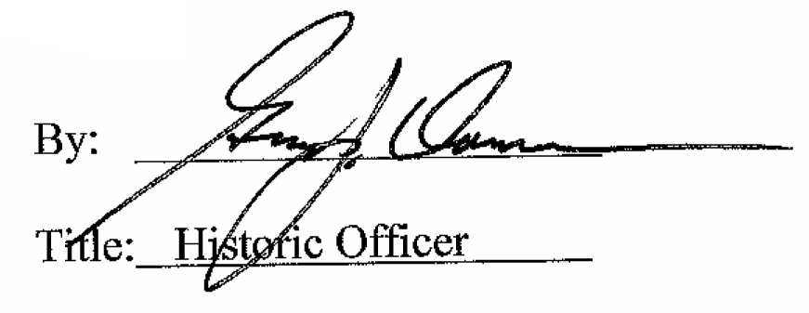

Date of Meeting: July 6, 2016

